Threads vs Instagram vs TikTok: How to Choose the Right Advertising Platform in 2026
In social media advertising, choosing the wrong platform can waste even the biggest budget. In recent years, TikTok has surged with its algorithm-driven traffic model, Instagram remains the core battlefield for brand advertising, and Meta’s newer platform Threads has also begun opening up to advertisers.
Faced with three completely different traffic systems, user demographics, and risk-control mechanisms, how should advertisers choose? This article provides a systematic comparison covering platform features, advertising costs, ROI performance, and account suspension risks, helping you spend every advertising dollar more effectively.
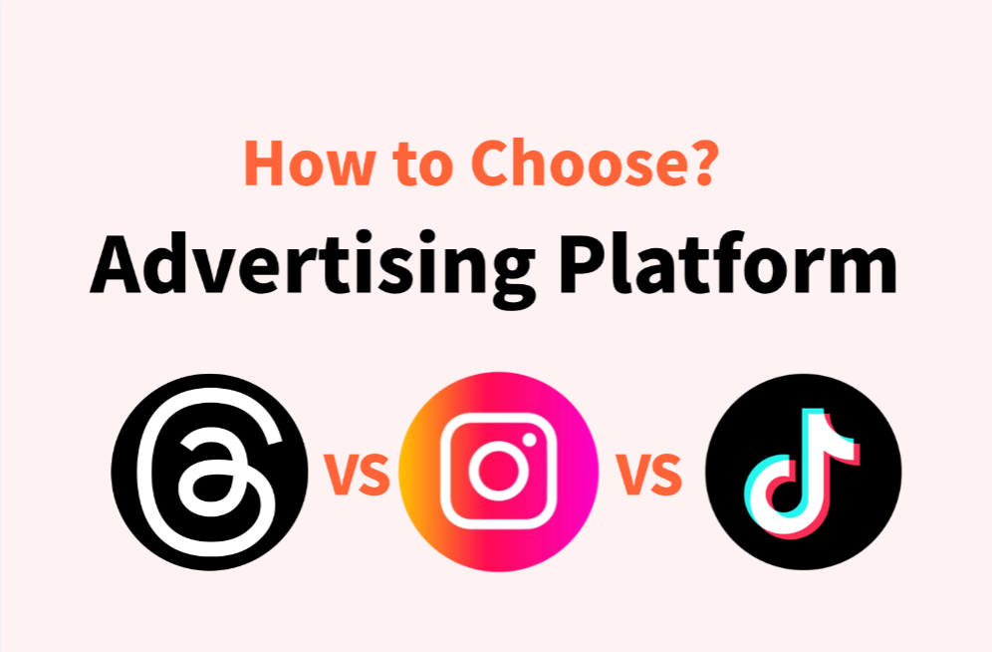
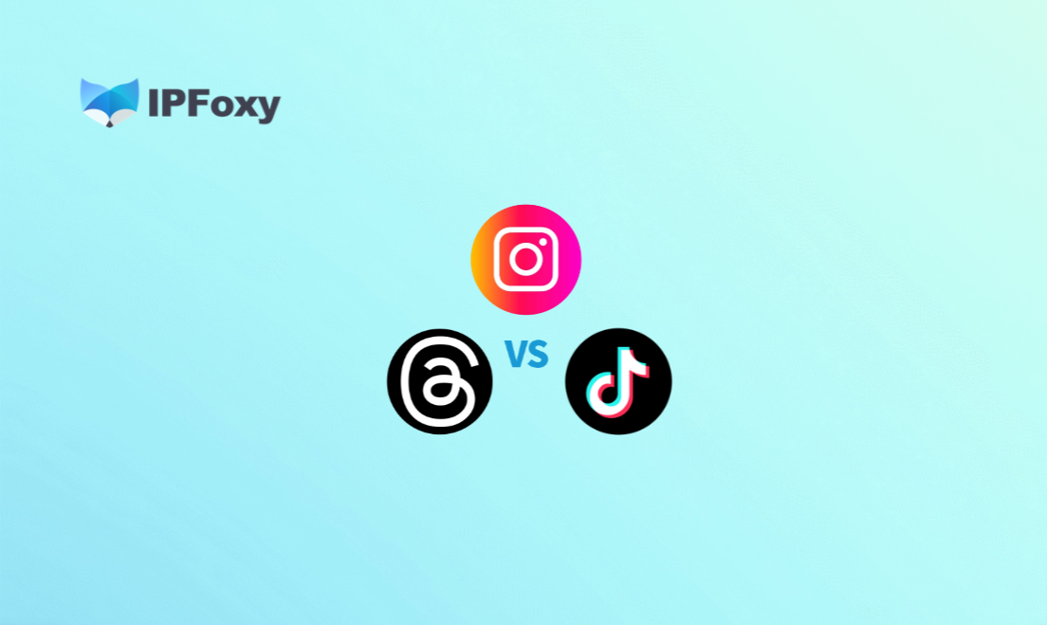

I. Why Do Advertising Results Differ So Much Across Social Media Platforms?
Many advertisers make the same mistake: they copy successful creatives and strategies from Platform A directly to Platform B, only to see ROI collapse. The root cause usually comes down to three key differences.

1.Different Traffic Distribution Logic
Different traffic systems create major differences in ad “cold start” costs and scaling strategies.
Instagram relies on a combination of social connections and interest-based distribution, where follower relationships remain an important traffic foundation.
TikTok is driven primarily by recommendation algorithms. A single viral video can reach massive audiences regardless of follower count.
Threads currently focuses more on text discussions and topic amplification, with traffic depending heavily on reposts, replies, and conversation engagement.

2.User Demographics Determine Conversion Rates
Platform user structures directly impact conversion funnel efficiency.
Instagram users span a broader age range (18–44), make relatively rational purchasing decisions, and tend to accept premium brand pricing more easily.
TikTok’s core audience is concentrated in the 18–34 demographic, where impulse buying behavior is stronger, making it ideal for fast-moving consumer products and entertainment-related offers.
Threads currently attracts more tech professionals, media workers, and creative industry users, making it more suitable for B2B software and SaaS products.
Even with high click-through rates, mismatched audience targeting often results in disappointing conversions.

3.Differences in Advertising Costs and ROI
CPM (cost per thousand impressions) and CPC (cost per click) vary significantly across the three platforms.
Instagram has a mature ad ecosystem with intense competition, which generally leads to higher costs.
TikTok still benefits from traffic growth momentum, with CPMs often lower than Instagram and relatively moderate acquisition costs.
Threads advertising is still in its early stage. Traffic costs remain relatively low, but conversion paths are not fully optimized yet, so ROI should be evaluated based on broader branding goals.
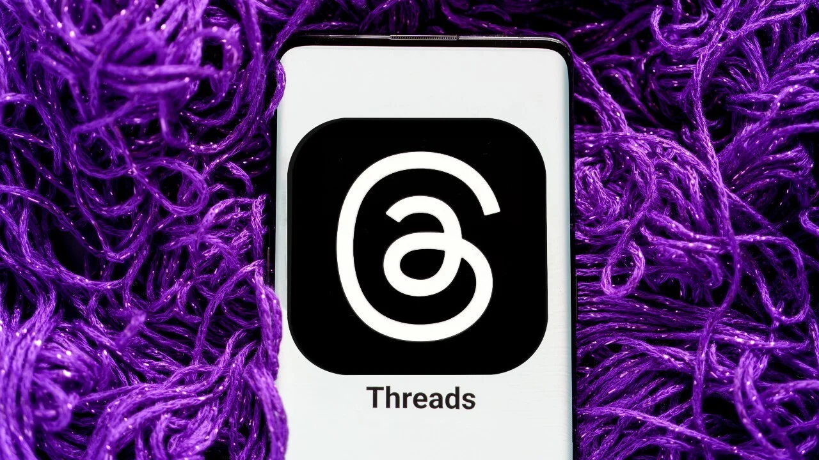

II. Threads vs Instagram vs TikTok: In-Depth Comparison
After understanding the underlying logic behind platform selection, let’s compare the three platforms across their most important metrics.

1.Platform Features and Content Types
Category | Threads | Instagram | TikTok
Platform Style | Text discussions and opinions | Visual-first images and short videos | Entertainment-focused short videos
Main Content Types | Posts, replies, reposts | Reels, Stories, posts, live streams | Short videos, live streams, challenges
Main User Age Group | 25–40 | 18–44 | 18–34
Core User Motivation | Discussions and information | Discovery, shopping inspiration, entertainment | Entertainment, shopping, trends

2.User Growth and Traffic Trends
Instagram now exceeds 2 billion monthly active users, offering massive ad inventory but intense competition. TikTok has surpassed 1.5 billion monthly active users globally, with Southeast Asia and North America still showing strong growth momentum. Since launching in 2023, Threads has experienced fluctuating growth but currently maintains around 150 million monthly active users. Its traffic potential is not yet fully saturated, giving early advertisers more room for lower-cost exposure.

3.Advertising System Comparison
Instagram runs through Meta Ads Manager, offering advanced targeting capabilities based on interests, behaviors, custom audiences, lookalike audiences, and retargeting options.
TikTok Ads operates independently through TikTok for Business. Its Spark Ads feature allows advertisers to convert organic content into paid ads, reducing user resistance to promotional content.
Threads advertising is currently managed through Meta Ads Manager alongside Instagram campaigns, although independent targeting features are still evolving.

4.Ad Review and Risk-Control Systems
Instagram’s review system is mature but strict. Categories such as finance, healthcare, and wellness often require additional verification documents. Repeated violations can trigger account restrictions.
TikTok applies stricter cultural-sensitivity reviews, and approval standards can vary significantly between regions.
Threads currently follows Meta’s overall advertising policies. Compared with Instagram, enforcement is slightly more lenient for now, but moderation standards will likely tighten as commercialization expands.


III. Threads vs Instagram vs TikTok: Practical Advertising Strategies
Understanding platform differences is only the first step. Turning that knowledge into effective execution is what ultimately matters.

1.How to Reduce Social Media Ad Account Risks
Instagram, Threads, and TikTok each have different suspension triggers.
- Instagram / Threads (Meta ecosystem): abnormal IP changes, multi-account associations from the same device, inconsistent payment information, and repeated policy violations can all trigger risk controls.
- TikTok: IP monitoring and device fingerprint detection are particularly strict. Registering or managing multiple ad accounts under the same IP and device environment significantly increases suspension risk. Repeatedly submitting rejected creatives can also escalate account risk scores.
Many ad accounts are suspended not because of ad creatives, but because the platform detects suspicious environment associations. TikTok and Meta platforms simultaneously analyze IP addresses, device fingerprints, cookies, and login behavior.
The core strategy for reducing account risk includes maintaining stable network environments and isolating browser environments:
- Stable Network Environment: Assign a fixed IP to each advertising account to avoid cross-region login behavior. For Instagram and TikTok campaigns, IP quality directly affects account trust levels. Using a dedicated static residential proxy for primary accounts is generally recommended. Teams managing multiple long-term advertising accounts often use providers like IPFoxy Proxies to obtain real local residential dedicated static residential proxies across 200+ countries and regions, helping maintain geographic consistency and reduce abnormal-login risk signals.
- Anti-detect Browser Isolation: Use an anti-detect browser to create isolated environments for each account, including separate cookies, Canvas fingerprints, and WebGL parameters. Combined with dedicated proxies, this creates a “one account, one browser profile, one IP” setup that helps reduce account association risks across Meta and TikTok platforms.
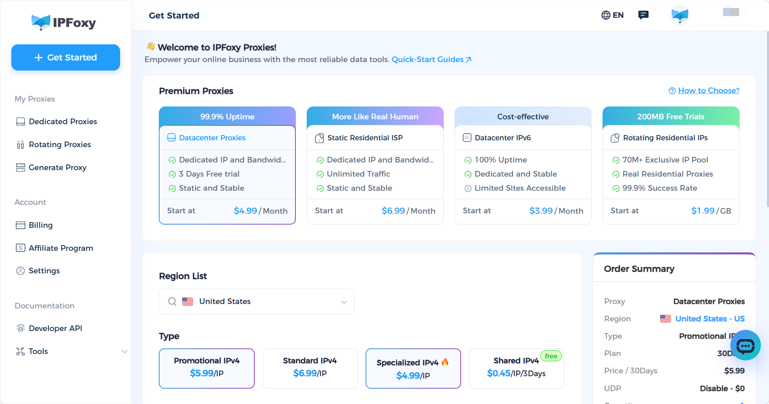

2.New Ad Account Warm-Up Strategy
Newly registered ad accounts should never start with aggressive spending immediately. A gradual warm-up process is safer:
- Day 1–3: Browse content only and simulate normal user activity
- Day 4–7: Publish limited organic content and complete profile information
- Day 8–14: Start small-budget ad testing
- After Day 15: Gradually increase budget while monitoring account health indicators
Since Threads currently has a lower advertising threshold, the warm-up period can be slightly shorter, though account consistency within the Meta ecosystem is still recommended.

3.Core Advertising Tips by Platform
Threads: Focus primarily on organic-style content. Build engagement and account authority through interactive posts before adding paid promotion. Opinion-based or debate-driven content tends to generate stronger organic reach.
Instagram: Prioritize testing Reels ads. Use A/B testing tools to compare creatives and combine campaigns with retargeting audiences to improve ROI.
TikTok: Use Spark Ads to amplify organically successful content while reducing the “advertisement feel.” Localized, native-style creatives generally outperform polished studio-style productions. Participating in trending challenges can also increase traffic exposure.


IV. FAQ

1.Is Threads advertising worth testing now?
Threads advertising is still in its early stage, with relatively low traffic costs and limited competition. It works well for brand exposure and content testing. However, conversion systems are still developing, so smaller experimental budgets combined with Instagram campaigns are usually the safest approach.

2.Why do TikTok ads get rejected?
Review TikTok’s advertising policies carefully. The most common causes are exaggerated claims, landing pages that do not match ad creatives, and account histories with previous violations.

3.What should I do if my Instagram ad account keeps getting restricted?
First identify the root cause. Review recently rejected ads, verify payment information consistency, and check whether login IPs have changed frequently. If the account has already been restricted, submit an appeal through Meta Business Support and prepare backup accounts to avoid campaign interruptions.

V. Conclusion
Threads, Instagram, and TikTok each provide unique advertising advantages. There is no universal “best platform” — the right choice depends on your product positioning, target audience, and advertising budget.
On top of that, maintaining isolated account environments, following platform advertising policies, and continuously optimizing creatives are the real foundations for achieving stable positive ROI across all three platforms.
If you are planning a multi-platform advertising strategy, it is usually best to start with the platform offering the lowest traffic costs, validate your conversion funnel with smaller budgets, and then gradually scale into a broader multi-platform advertising system.

